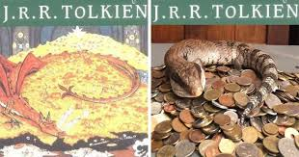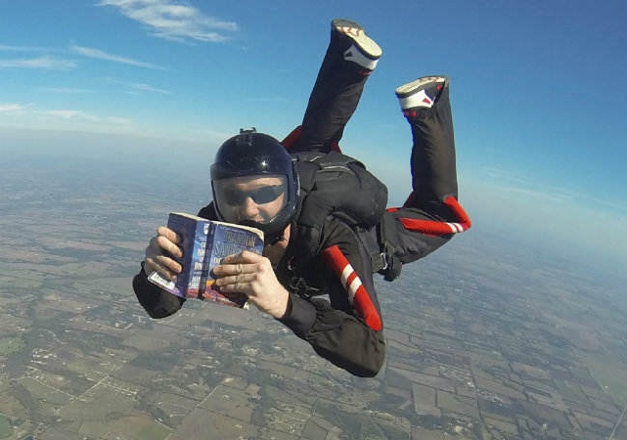**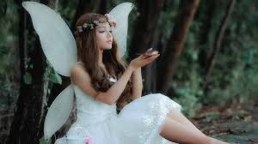WORLD BOOK DAY 2021: SHARE A STORY!**

**RECREATE YOUR FAVOURITE LITERARY MOMENT**

***Turn your staircase into Juliet’s balcony, your kitchen into Jekyll’s laboratory or your beloved spaniel into the ferocious Hound of the Baskervilles. Recreate your favourite literary moment using items from around your home, take a photograph (or two!) and send them to us with a caption attached. We can’t wait to see your choices!***

***READING IN STRANGE PLACES…***

***You may not be able to take to the skies with a book of your choice but where else could you sit down and enjoy a chapter or two? In a wheelbarrow? Up a tree? It is up to you! Wherever you choose, send us a picture of your unusual reading location!***

**FAIRIES, SKIP HENCE!**

***If you are in Year 7, celebrate your love of A Midsummer Night’s Dream with this fairy challenge. Create your own fairy, from paper or fabric, and send us a picture of them reclining on your bookshelves.***

**TAKE A SHELFIE!**

***Are your bookshelves alphabetised? Colour co-ordinated? Organised by genre? Regardless of how you arrange your books, we want to see your shelfies! Show off your favourite books by sending us a picture of your beautiful bookshelves!***



**You can share all your submissions with us here:**

<https://wisf-my.sharepoint.com/:f:/g/personal/s_didlick_kingshighwarwick_co_uk/EnmUF7qd_NNCiSvsEiz8T_wBO_ELZTN15GaQbR6TYJonjQ?e=8eIT55>

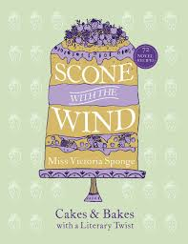

**TELL A STORY THROUGH BAKING**

***Can you tell a story through baking? The Crepes of Wrath. Catcher in the Pie. The Tell-Tale Tart. You decide! Cook up a literary storm and tell us all about it! Pun-filled caption optional.***

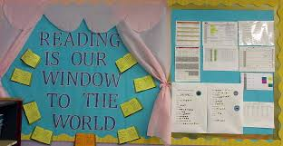

**CREATE A WINDOW DISPLAY**

***Create a World Book Day window display to encourage passers-by to read or create a ‘guess the book’ display so that those who walk past can ponder and enjoy! Send across a photo or two so everyone in the school community can enjoy it too!***



**READ A FEEL-GOOD BOOK**

***Read a feel-good book:***<https://reading-well.org.uk/books/mood-boosting-books/chosen-by-young-people-2017>

***Read something that really makes you think:***<https://www.youtube.com/watch?v=WvvHaCg6V4E&t=5s>



**SHAKESPEARE SONGS**

***Watch this Ex Cathedra video*:** <https://wisf-my.sharepoint.com/:v:/g/personal/c_renton_kingshighwarwick_co_uk/EZMAB_RneK5LgoY1yNZ3_xUBFdr1FjOgJORH79TPPYy1eQ?e=7VjMBs>

***Then compose your own music to some words taken from a Shakespearean play. Hint: You may want to seek out sections of the plays that already rhyme to make things easier. We look forward to hearing the Bard reimagined.***



**You can share all your submissions with us here:**

<https://wisf-my.sharepoint.com/:f:/g/personal/s_didlick_kingshighwarwick_co_uk/EnmUF7qd_NNCiSvsEiz8T_wBO_ELZTN15GaQbR6TYJonjQ?e=8eIT55>