

King’s High Food Magazine


Table of Contents

Christmas Crossword
24 Days of Festive Food
History of traditional christmas food
Gardening near christmas
Interview with Our head chef
Christmas word search
Christmas connections



Homemade Hot chocolate


- 250ml milk (any kind will work)
- 1 tbsp cocoa powder
- 1-2 tbsp soft light brown sugar
- 25g chocolate (whatever kind you want)
- 1 tbsp whipped cream or squirty cream

Heat the milk, cocoa, sugar, and chocolate in a small pan over a medium heat until steaming and the chocolate has melted. Whisk to dissolve the cocoa.
Pour into a mug, then add the cream to float on top. Grate over some chocolate to serve.

For more information, please see the link: https://www.bbcgoodfood.com/recipes/homemade-hot-chocolate

Christmas tree brownies

- 200g unsalted butter
- 200g dark chocolate
- 4 medium eggs
- 275g caster sugar
- 100g plain flour
- 50g cocoa powder
- 100g milk chocolate chips
- 100g white chocolate chips
Decoration:
- Candy canes
- 100g unsalted butter
- 200g icing sugar
- Green food colouring
- Sprinkles
- Melt butter and dark chocolate, then let cool.
- Whisk eggs and sugar until thick and pale.
- Fold in the cooled chocolate mixture gently.
- Add sifted flour + cocoa, then stir in chocolate chips.
- Bake in a square tin for ~25–30 mins and let cool fully.
- Cut into triangle “trees” and add a candy cane stick.
- Pipe green buttercream on top and decorate with sprinkles.
For more information, please see the link: https://www.janespatisserie.com/2015/12/12/christmas-tree-chocolate-brownies/#wprm-recipe-container-11645
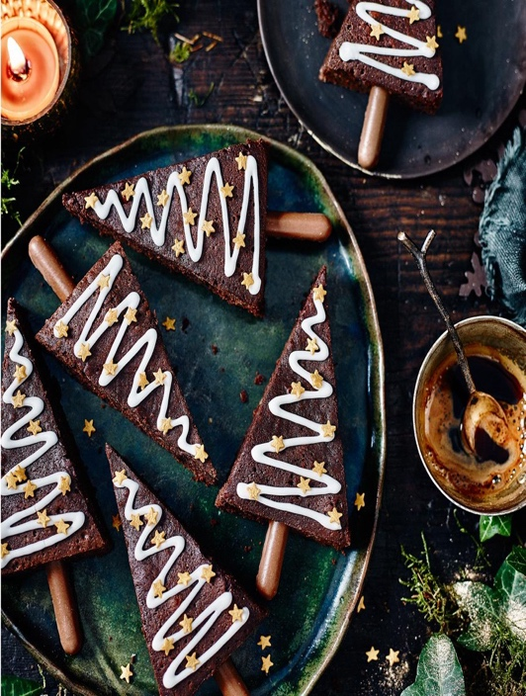

Stocking pizza


Dough
- 500g strong white bread flour
- 1 tsp salt
- ½ tsp dried yeast
- 300-350ml warm water
- Oil (for greasing)
Sauce
- 85g tomato paste
- 200g tomato sauce (passata)
- 2 tbsp dried herbs
- ½ tsp garlic powder
- ½ tsp onion powder
- 1 tsp sugar
- ¼ tsp black pepper
Toppings
- Shredded mozzarella
- Any additional toppings e.g pepperoni, basil, mushrooms, peppers

- Mix flour, salt, and yeast.
- Add warm water gradually and mix until a soft dough forms.
- Knead for 8–10 minutes until smooth.
- Place in an oiled bowl, cover, and rise for 1–1.5 hours until doubled.
- Mix tomato paste, passata, herbs, garlic powder, onion powder, sugar, and pepper. Set aside.
- Preheat oven to 220–240°C.
- Punch down dough and divide into 2 pizzas (or keep whole for 1 large).
- Roll out dough, place on a tray, and spread a thin layer of sauce.
- Add mozzarella and your chosen toppings.
- Bake for 12–15 minutes until golden and bubbling.
For more information, please see the link: https://www.delish.com/cooking/recipe-ideas/recipes/a56686/pizza-stockings-recipe/

Christmas NYC cookies


Cookies
- 125g unsalted butter
- 175g light brown soft sugar
- 1 large/ medium egg
- 1 tsp vanilla extract
- 300g plain flour
- 1 ½ tsp baking powder
- ½ bicarbonate of soda
- ½ tsp sea salt
- 100g milk chocolate
- 100g white chocolate
- 100g green/ red M&M’s
Decoration
- 100g – 150g dark chocolate
- Christmas sprinkles
- Beat the butter and light brown sugar until creamy.
- Add the egg and vanilla, then beat again.
- Beat in the flour, baking powder, bicarbonate of soda, and salt.
- Form a dough.
- Mix in the chocolate chips and red/green M&Ms.
- Roll into 8 large balls (about 120g each).
- Chill: freeze for 30 minutes or refrigerate for about 1 hour.
- Preheat oven to 180°C fan / 200°C regular.
- Place cookie balls on a lined tray and bake for 11–13 minutes.
- Let them cool fully on the tray.
- Melt chocolate, dip half of each cookie, and add Christmas sprinkles.
- Allow the chocolate to set completely.
For more information, please see the link: https://www.janespatisserie.com/2021/12/11/christmas-nyc-cookies/

Homemade mince meat

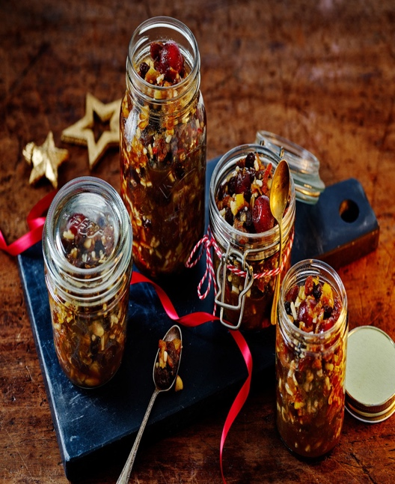

- 250g raisins
- 375g currants
- 100ml brandy
- Zest of 1 lemon (juice of ½)
- 300g shredded suet
- 250g dark brown sugar
- 85g chopped mixed peel/ or glacé cherries
- ½ small nutmeg (grated)
- 1 large Bramley apple (peeled and grated)

- Soak the raisins and currants in the brandy and lemon juice for an hour
- Add the rest of the ingredients and mix throughly
- Spoon the mixture into clean sterile jars (the best way to sterilise jars is to dish wash them on a high heat).

For more information, please see the link: https://www.bbcgoodfood.com/recipes/traditional-mincemeat

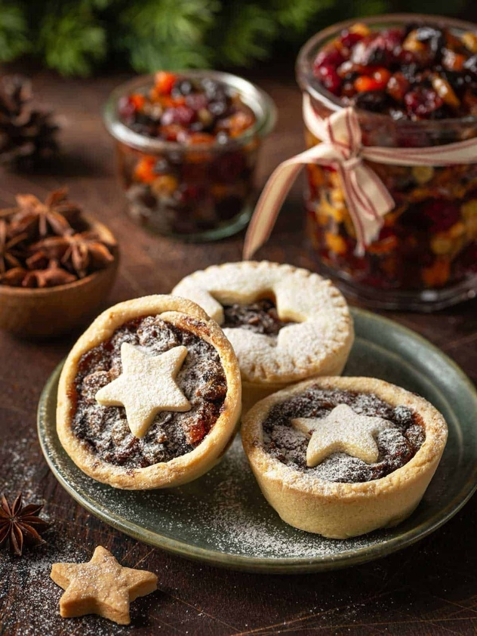
Mince pies

- 225g cold butter
- 350g plain flour
- 100g golden caster sugar
- 280g mincemeat (homemade or store bought)
- 1 small egg (beaten)
- Icing sugar (to dust)

- Rub the butter into the flour, then mix in the golden caster sugar and a pinch of salt
- Combine the pastry into a ball (without any liquid) and knead it briefly, this can be used immediately, or chilled for later
- Heat the oven to 200C/ 180C fan. Line 18 holes of two 12-hole cupcake tins
- Put the pastry in each hole, you can do this by pressing a small ball of pastry and moulding it to the size of the tin
- Spoon the mincemeat into the pies
- Use any extra pastry to make some fun shapes such as stars to add to the top, or you can make a lid by cutting a circle the same size as the top of the pie, but make sure to add a small cut in the top to allow steam to be released
- Brush the beaten egg onto each pie and bake them for 20 minutes until golden.
- Dust with icing sugar.

For more information, please see the link: https://www.bbcgoodfood.com/recipes/unbelievably-easy-mince-pies


- 300g gluten free plain flour
- 1 ½ tsp xanthan gum
- 3 tbsp caster sugar
- 145g unsalted butter (cold)
- 2 large eggs
- A jar of mincemeat (store bought or homemade)
- 1 large egg (beaten to egg wash)
- Mix gluten-free plain flour and xanthan gum.
- Rub in very cold butter until it resembles breadcrumbs.
- Stir in caster sugar.
- Beat two eggs separately, then add gradually to form a dough.
- Wrap and chill the dough in the fridge or freezer for 30 minutes.
- Preheat oven to 180°C fan / 200°C.
- Grease a 12-hole muffin or cupcake tin.
- Roll out chilled pastry to about 3mm thick.
- Cut bases (~9–10 cm cutter) and press into the tin.
- Add 1.5 tsp mincemeat into each case.
- Re-roll leftover pastry.
- Option A (Star tops): Cut stars, attach with egg wash/milk, brush the top.
- Option B (Lids): Cut 7.5 cm rounds, place on top, poke a steam hole, brush, and sprinkle sugar.
- Bake for 20 minutes until golden.
- Allow to cool, then remove from the tin.
- Dust with icing sugar.
For more information, please see the link: https://glutenfreecuppatea.co.uk/wprm_print/gluten-free-mince-pies-recipe-best-ever-dairy-free-option
Gluten Free Mince Pie

Christmas tree dough balls



Dough
- 500g strong white bread flour
- 7g of yeast
- 2 tsp golden caster sugar
- 100g butter (melted)
- 150g mozzarella
Garlic butter
- 140g butter
- 4 garlic cloves minced
- Small bunch parsley (finely chopped), or 1 tbsp dried herbs

- Mix flour, yeast, sugar, salt, melted butter, and warm water to form a soft dough, then knead.
- Let the dough rise until doubled in size.
- Divide dough into pieces, wrap mozzarella in each, and arrange in a Christmas tree shape on a lined tray.
- Let the shaped dough prove again until nearly doubled.
- Bake at 200°C (180°C fan) for 20–25 minutes until golden.
- Make garlic butter by melting butter with crushed garlic.
- Brush baked bread with garlic butter and sprinkle with parsley, or dried herbs.
For more information, please see the link: https://www.bbcgoodfood.com/recipes/christmas-tree-garlic-bread

Mini Sausage Rolls


- 350g puff pastry (store bought or homemade)
- 400g plain sausage meat
- 2 garlic cloves (minced)
- ¼ - ½ tsp chilli flakes
- 1 tsp mixed herbs
- Pinch of salt and pepper
- 65ml water
- 1 egg (beaten)

- Preheat the oven to 210 °C (190 °C fan) and line two baking trays with parchment paper.
- Blend the sausage meat with garlic, chilli flakes, mixed herbs, salt, pepper, and water until smooth.
- Roll out a puff pastry sheet and cut it into two long strips.
- Spread half of the sausage mixture along one strip (leaving ~1 cm from the edge), then fold pastry over and seal with beaten egg.
- Repeat with the other strip, then cut each into 12 pieces (total ~24 mini rolls).
- Place rolls on the trays with the seam underneath, brush the tops with more beaten egg.
- Bake for 25–30 minutes, until the sausage is cooked through and the pastry is golden.
- Let them cool for about 10 minutes before serving (they are good hot or cold).

For more information, please see the link: https://www.janespatisserie.com/2022/02/18/mini-party-sausage-rolls/#wprm-recipe-container-20101

Hot chocolate cupcakes

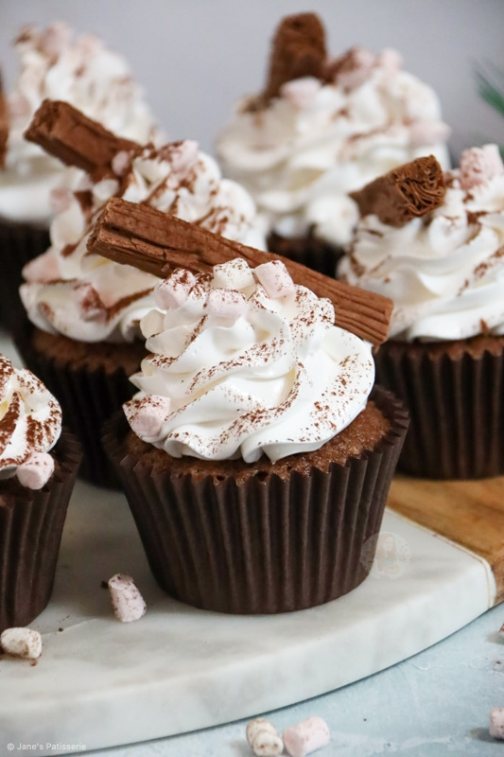
Cupcakes
- 175g unsalted butter (room tempurature)
- 175g light brown soft sugar
- 135g self raising flour
- 40g hot chocolate powder
- 3 medium eggs
Marshmallow buttercream
- 3 medium egg whites
- 100g caster sugar
- 1 tsp vanilla extract
- 100g caster sugar
- 65ml water
Decoration
- Mini marshmallows
- Flakes
- Hot chocolate powder
- Preheat the oven to 180 °C (160 °C fan) and line a 12-hole muffin tin with cases.
- Beat together butter and light brown sugar until creamy.
- Mix in the self-raising flour, hot chocolate powder, and eggs until smooth.
- Divide the batter between the cupcake cases and bake for 19–21 minutes until cooked through.
- Let the cupcakes cool completely.
- Whisk egg whites until stiff, gradually add caster sugar, then whisk in vanilla.
- Boil a syrup of caster sugar and water to 113 °C, then drizzle into the whisking meringue to make marshmallow frosting.
- Continue whisking for 5 minutes until firm.
- Pipe the frosting onto cooled cupcakes.
- Decorate with mini marshmallows, a flake, and a dusting of hot chocolate powder.
For more information, please see the link: https://www.janespatisserie.com/2022/12/12/hot-chocolate-cupcakes/

Gingerbread women



- 100g salted butter
- 3 tbsp golden syrup
- 100g dark muscovado sugar
- ½ tsp bicarbonate of soda
- 1 tbsp ground ginger
- 1 tsp ground cinnamon
- 225g plain flour
- 50g icing sugar
- Melt the butter, golden syrup, and dark muscovado sugar together in a pan, then leave to cool slightly.
- Mix the flour, bicarbonate of soda, ginger, and cinnamon in a bowl.
- Pour in the syrup mixture and bring together into a dough with your hands (add a little milk if needed).
- Roll the dough between two sheets of baking paper to about ½ cm thick, then chill for 1 hour.
- Preheat the oven to 190°C (170°C fan) and line a baking tray.
- Cut out shapes with cookie cutters and place them spaced apart on the tray.
- Bake for 10–12 minutes, then cool completely.
- Mix icing sugar with a little water to make icing and decorate once cooled.
For more information, please see the link: https://www.bbcgoodfood.com/recipes/ultimate-easy-gingerbread

Gluten free gingerbread women



- 100g salted butter
- 3 tbsp golden syrup
- 100g dark muscovado sugar
- ½ tsp bicarbonate of soda
- 1 1/2 tbsp ground ginger
- 1 tsp ground cinnamon
- 225g gluten-free plain flour
- 50g icing sugar
- Melt the butter, golden syrup, and dark muscovado sugar together in a small pan, then let it cool slightly.
- Mix the bicarbonate of soda, ginger, cinnamon, and gluten-free plain flour in a bowl.
- Pour the warm butter mixture into the dry ingredients and bring it together with your hands to form a dough.
- Sandwich the dough between two sheets of baking paper, flatten to about ½ cm thick, and chill for about 1½ hours.
- Heat the oven to 190°C (170°C fan) and line a baking tray.
- Cut shapes from the chilled dough, place on the tray, and bake until golden.
- Mix icing sugar with a little water to make thick icing, then decorate once cooled.
For more information, please see the link: https://www.bbcgoodfood.com/recipes/gluten-free-gingerbread

Christmas mock tail

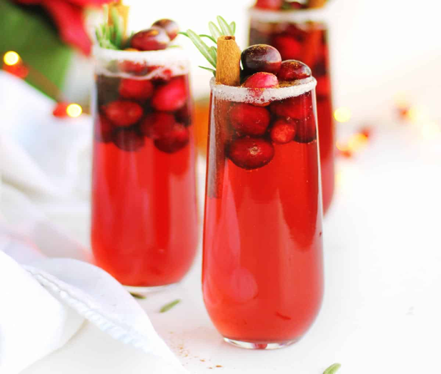

- 6 mint leaves
- 1 tsp maple syrup
- 50ml cranberry juice
- 25ml apple juice
- 15ml lime juice
- Fill the glass with sparkling water
- Splash of apple cider vinegar

- Clap the mint leaves to release their aroma, then muddle gently with maple syrup in a shaker or glass.
- Add lime juice, apple juice (or cider), and cranberry juice, along with ice, then shake well.
- Strain the mixture into a glass filled with ice.
- Top up with sparkling water, ginger beer, or non-alcoholic sparkling wine.
- Garnish with cranberries, mint, and/or lime.

For more information, please see the link: https://mindfulmocktail.com/holiday-mocktail/#recipe

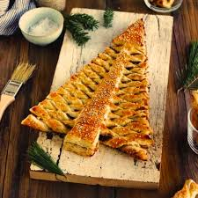
Pesto Christmas tree

- 2 sheets of ready rolled puff pastry (or homemade)
- 6 tbsp pesto
- 1 egg beaten
- 25g parmesan cheese
- Preheat the oven to 200°C (180°C fan).
- Spread pesto evenly over one sheet of puff pastry, then top with a second sheet.
- Cut out a Christmas tree shape and a star from the trimmings.
- Transfer the tree to a baking tray, brush with beaten egg, and sprinkle with Parmesan.
- Cut “branches” into the sides of the tree and twist them alternately from bottom to top.
- Bake for 15–20 minutes until the pastry is risen and golden.
- Use leftover pastry to make small stars or strips, sprinkle with sesame seeds if desired, and bake separately.

For more information, please see the link: https://www.recipesmadeeasy.co.uk/pesto-christmas-tree-and-fizz/#recipe

Yule log

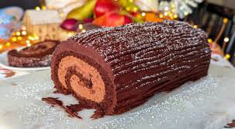

- 4 large eggs
- 100g caster sugar
- 65g self-raising flour
- 40g cocoa powder
- 300ml double cream
- 300g dark chocolate

- Preheat the oven to 180°C (160°C fan) and line a Swiss roll tin with baking paper.
- Whisk eggs and sugar together until thick, pale, and doubled in volume.
- Gently fold in sifted cocoa powder and plain flour until fully combined.
- Pour the mixture into the prepared tin and spread evenly.
- Bake for 10–12 minutes until just set.
- While hot, roll the sponge in a tea towel dusted with cocoa or icing sugar and leave to cool completely.
- For the filling, beat cream until thick and fold in sifted icing sugar and vanilla.
- Unroll the cooled sponge, spread the filling evenly, then re-roll tightly.
- Spread chocolate ganache or frosting over the outside of the log.
- Use a fork to create a bark-like texture on the frosting and decorate as desired.
For more information, please see the link: https://www.bbc.co.uk/food/recipes/yule_log_15656

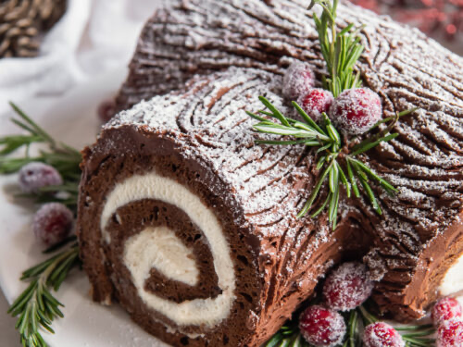
Gluten-free Yule log

- For the sponge
- 4 large eggs
- 100g caster sugar
- 65g gluten-free self-raising flour
- 40g cocoa powder
- ¼ tsp xanthan gum
- For the icing:
- 675g icing sugar
- 45g cocoa powder
- 65g butter
- 2 tsp vanilla extract
- 125ml milk
- Icing sugar for dusting

- Grease a Swiss roll tin and line it with baking paper.
- Whisk together sugar and eggs until light and frothy.
- Sift in gluten-free self-raising flour, xanthan gum, and cocoa powder, then fold into the egg mixture.
- Pour into the tin and bake for about 9 minutes until just risen.
- While still warm, invert the sponge onto fresh paper, trim the edges, score a few lines, and roll it up to cool fully.
- For the icing, beat together icing sugar, cocoa powder, softened butter, vanilla, and milk.
- Unroll the cooled sponge, spread a thick layer of icing, then re-roll tightly.
- Cut a quarter off to use as a “branch,” trim the cut end at an angle, and attach it.
- Cover the log with the remaining icing, then use a fork or knife to create a “wood bark” texture.
- Dust with icing sugar and decorate with holly or other festive decorations.
For more information, please see the link: https://glutenfreecuppatea.co.uk/2018/12/07/gluten-free-yule-log-recipe-dairy-free-low-fodmap/

Frostbite punch



- 200ml white cranberry juice
- 100ml sparkling water
- 1 drop blue food colouring
- A slice of lime
- Blueberries (for decoration)
- Ice

- Mix the cranberry juice, sparkling water and blue food colouring. Serve in a glass with the ice, blueberries, and a thin slice of lime

Cranberry sauce

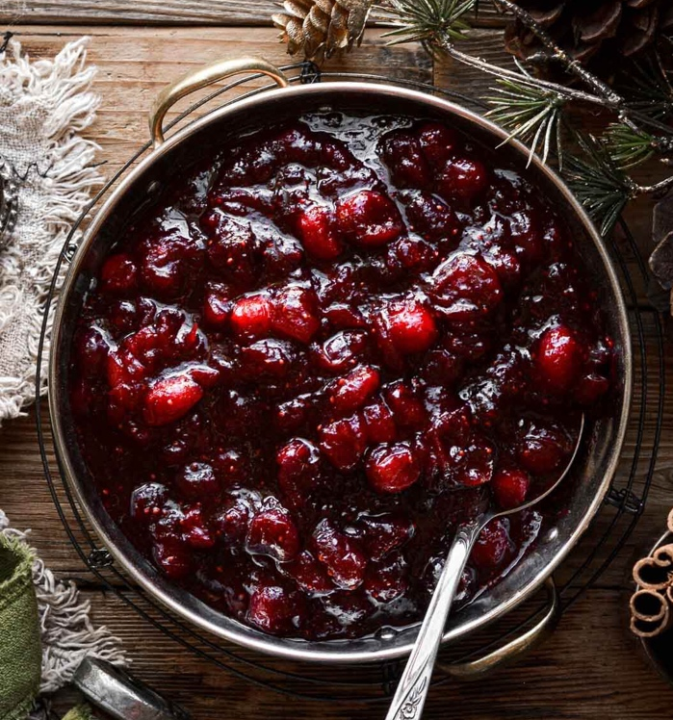

- 100g light muscovado sugar
- 100ml orange juice
- 250g pack of fresh or frozen cranberries

- Put the sugar and orange juice into a pan and bring to a boil.
- Add the cranberries and simmer until they are tender but still hold their shape (about 5 mins for frozen, 8–10 mins for fresh).
- Let the sauce cool — it will thicken as it cools.
- Store in the fridge for up to a week.
- Before serving, bring it to room temperature.

For more information, please see the link: https://www.bbcgoodfood.com/recipes/really-simple-cranberry-sauce

Melting snowman biscuits



- 375g plain flour
- ½ tsp baking powder
- ½ tsp salt
- 175g butter
- 165g caster sugar
- 1 tsp vanilla extract
- 1 egg
- 160g icing sugar
- 1 ½ tbsp milk
- 24 white marshmallows
- Chocolate sprinkles (for the arms)
- 1 pack Mini M&M’s (for the buttons)
- Coloured edible icing (black and orange)

- Sift flour, baking powder, and salt into a bowl. Beat butter and caster sugar until pale and creamy, then mix in vanilla and egg. Fold in the flour mixture.
- Turn dough onto a lightly floured surface, knead briefly until smooth, divide into two discs, wrap, and chill for 30 minutes.
- Preheat oven to 180°C and line two baking trays with parchment.
- Roll out one disc to 5 mm thick between baking paper, cut 12 rounds (7 cm), place 3 cm apart on trays, and bake 12–15 minutes until lightly golden. Repeat with second disc and cool biscuits.
- Make icing by mixing icing sugar with enough milk to spread. Spread over cooled biscuits to form the “melted body.”
- Cut small triangles from candies to form noses and attach to marshmallows with icing. Pipe eyes and mouths on marshmallows and place marshmallow heads on iced biscuits. Wrap thin candy strips around heads as scarves.
- Decorate with red and green mini M&Ms for buttons and pipe arms with icing.
For more information, please see the link: https://www.taste.com.au/recipes/melted-snowmen-biscuits/pu2dhpvt

Panettone

Dough
- 600g plain flour
- 1 tbsp instant yeast
- 160ml water
- 5 large eggs
- Zest of 1 orange
- 68g sugar
- 2 tsp vanilla extract
- 10g sea salt
- 170g unsalted butter
- 14g cold butter
- Vegetable oil (for greasing)
- Fruit and nuts:
- 75g dark raisins
- 75g gold raisins
- 75g candied orange peel
- 60ml dark rum
- 60ml hot water
- 50g almonds (optional)

- Soak raisins and candied fruit in 60 ml hot water and 60 ml rum for 20–30 minutes, then drain.
- Make the sponge: mix 150 g flour, 9 g yeast, and 80 ml water into a smooth batter. Cover and let rise until bubbly (~30 min).
- Make the dough: combine the sponge with remaining 450 g flour, 68 g sugar, 9 g salt, 250 g eggs, orange zest, and vanilla. Knead until smooth.
- Gradually knead in 170 g softened butter until fully incorporated. Dough should be smooth, elastic, slightly sticky.
- Fold in drained fruit and optional almonds evenly. Place dough in an oiled bowl, cover, and let rise until doubled (1–2 hrs).
- Shape dough into a round loaf, place in a panettone mould, and let rise until near top of mould.
- Preheat oven to 180 °C (160 °C fan). Brush top with 14 g butter and sprinkle with almonds if desired.
- Bake 40–50 min, covering with foil if browning too quickly.
- Cool completely on a wire rack before slicing.
For more information, please see the link: https://www.simplyrecipes.com/recipes/panettone/

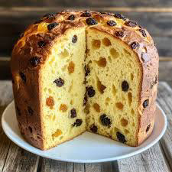

Pinecone brownies

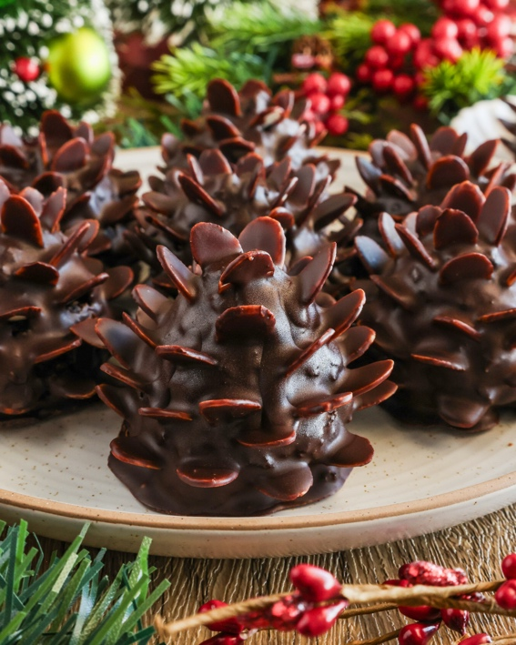

Dough
- 2 large eggs
- 100g granulated sugar
- 100g light brown sugar
- 113g unsalted butter
- 2 tsp vanilla extract
- 65g plain flour
- 35g cocoa powder
- A pinch of salt
- ¼ tsp baking powder
- 150g chocolate cereal
- 30g powdered sugar

- Preheat the oven to 175°C and line an 8×8-inch baking pan with parchment.
- Beat the eggs with both sugars on high speed for around 1 minute, until the mixture is light and creamy.
- Add the melted butter and vanilla, mix on medium until combined.
- Whisk in the flour, cocoa, salt, and baking powder until smooth.
- Fold the dry ingredients into the wet mixture using a spatula.
- Pour the batter into the prepared pan and spread evenly. Bake for 22–25 minutes.
- Cool the baked brownies completely.
- Scoop ~2 tbsp of brownie, roll into a ball, then shape into a cone.
- Press the chocolate cereal into the cone, starting at the top and working down in rings to mimic a pinecone.
- Dust each pinecone with powdered sugar for a snowy effect.
For more information, please see the link: https://chelsweets.com/pine-cone-brownies/#recipe



- 170g unsalted butter
- 113g cream cheese
- 300g granulated sugar
- 1 large egg
- 2 tsp vanilla extract
- 375g all purpose flour
- 1 tbsp cornflour
- ½ tsp baking powder
- ½ tsp salt
- Buttercream frosting
- 225g unsalted butter
- 3 tsp vanilla extract
- ½ tsp salt
- 450g icing sugar
- 60ml double cream
- Decoration
- 200g caster sugar (to dip the cookies in)
- 1 pack mini M&M’s (brown ones for the eyes and red ones for the ears)

- Make the cream-cheese cookie dough, divide it in half, wrap in plastic, and chill for about 2 hours (or 30 mins in freezer).
- Preheat the oven to 175°C and line two baking sheets.
- Roll out the dough to about 1/3 inch thick and cut out large circles for the bear bodies using a 2.5-inch cutter.
- Cut smaller circles (ears) from the remaining dough using a ¾-inch cutter, trim a bit so they sit flush, and attach two to each big circle.
- Chill the shaped cookies again (15 mins in fridge or 5 mins in freezer) to help them keep their shape.
- Bake for 12–14 minutes on the top rack, making sure not to let the edges brown. Let them cool on the tray for about 15 minutes, then transfer to a wire rack.
- Make vanilla buttercream frosting, adjust consistency with cream if needed, and put into a piping bag with a round tip (or cut a 1 cm hole).
- Once cookies are fully cool, pipe a thin layer of buttercream on top, then dip each into white sanding sugar so the top is fully coated.
- Pipe a small oval for the muzzle, press a chocolate chip for the nose, use black sprinkles for eyes, and red or pink sprinkles for ears.
- Repeat for all cookies, then enjoy!
For more information, please see the link: https://chelsweets.com/polar-bear-cookies/#recipe

Polar bear cookies

- 400g milk chocolate
- 200g dark chocolate
- 200g macadamia nuts
- 200g marshmallows
- 50g pistachios
- 50g glacier cherries
- 10g freeze dried strawberries

- Line the baking tin with baking paper. Make sure the baking paper has good overhang so that you can easily pull the rocky road out of the tin once it sets. Set aside.
- Place the macadamia nuts, marshmallows and pistachio nuts into a large bowl and stir to mix them up. Set aside.
- To melt the chocolate: Break the chocolate into small pieces and microwave on a low heat setting in 30 second bursts, stirring each time, until the chocolate is just melted. This can also be done in a pot over a very low heat, or over a double boiler (bain-marie). Make sure you stir the chocolate all the time until it has just melted.
- Pour the just melted chocolate into the bowl of nuts, marshmallows and Turkish delight, and using a large spoon, stir gently so that all the ingredients are coated well in chocolate. Pour the rocky road mixture into the baking tin and even it out around the tin using the spoon.
- Decorate the top while the chocolate is still soft by placing the extra pistachios all over, pressing them into the chocolate slightly. Repeat with the freeze-dried raspberries. With the last 2-3 raspberries, I like to crush them with my fingers and sprinkle this all over the top. Lastly sprinkle with desiccated coconut (optional).
- Cover and refrigerate for at least 1 hour or until set.
- Remove from the fridge and lift the set rocky road out of the tin onto a flat chopping surface. Using a large sharp knife, cut widthways into 6 even slices. These longer slices are great for gifts. Otherwise, you can cut each of the slices into 3 or 4 serving size pieces.
For more information, please see the link: https://www.katysfoodfinds.com/christmas-rocky-road/#recipe

Christmas rocky roads

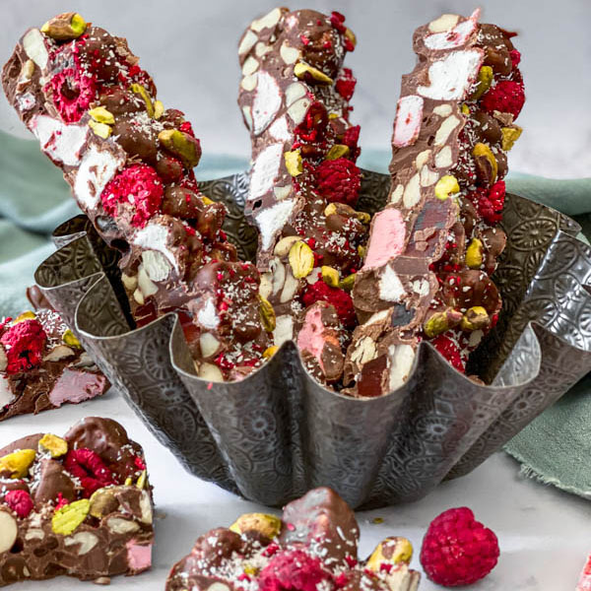

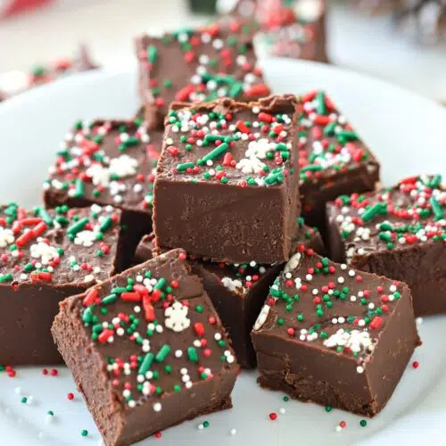

- 397g sweetened condensed milk
- 540g semi-sweet chocolate chips
- 57g butter
- 1 teaspoon vanilla extract
- 2 tablespoons Christmas sprinkles

- Prepare an 8x8 baking pan by lining it with parchment paper (or aluminium foil) and then spray it with non-stick cooking spray. Set aside.
- Microwave the chocolate chips, sweetened condensed milk, and butter in a medium bowl for 30-second intervals until the chocolate melts. Add the vanilla extract to the melted chocolate mixture and stir to combine.
- Pour the fudge into the prepared pan and smooth it with a rubber spatula into an even layer. Now, top it with festive sprinkles.
- Place the fudge recipe in the refrigerator to set for about 2 hours. Then, cut it into 1-inch pieces.

For more information, please see the link: https://www.suburbansimplicity.com/christmas-fudge/#recipe

Christmas fudge

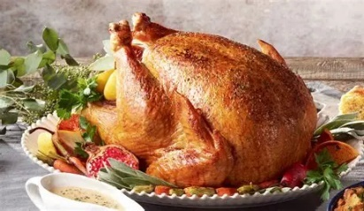
A Bit of History about British Traditional Christmas Foods

Roast Turkey
Originally, goose was the main Christmas bird in Britain.
- Turkey gained popularity in the 16th century, after being introduced to Britain from the Americas.
- It became widespread after Charles Dickens’ “A Christmas Carol” (1843) glorified the turkey as the “big prize” for the Cratchit family.
- By the 20th century, turkey was affordable for most households, replacing goose as the standard Christmas bird of choice.

Goose (the older tradition)
- Goose was the traditional Christmas meat for centuries, especially among working-class families.
- It was also connected with Michaelmas (an autumn feast), so farmers often raised birds for both occasions.
- Victorian charities sometimes paid for poor families to get a Christmas goose.
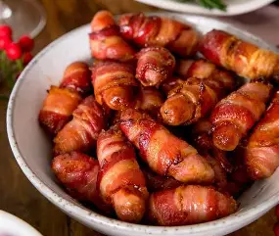

Pigs in Blankets
- The combination of sausages and bacon is old, but “pigs in blankets” as a Christmas essential is surprisingly modern, growing popular in the late 20th century.
- Their popularity exploded in the 1990s–2000s as supermarkets began offering pre-made versions.

Stuffing
- Stuffing has been used for centuries to keep meat moist and add flavor.
- Sage and onion became the British favorite by the Victorian era, thanks to cheap onions and herbs grown in home gardens.
- Chestnut stuffing was considered more luxurious.

Roast Potatoes
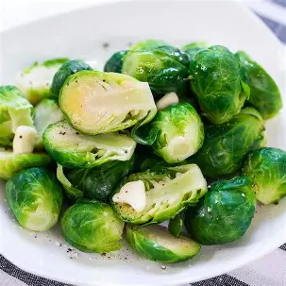
- Potatoes became a British staple in the 18th century but roasting them in fat became a Christmas tradition because festive meals historically used goose fat, perfect for crisp roasts.

Brussels Sprouts
- Sprouts arrived in Britain in the late 18th century from Belgium.
- They became common by Victorian times because they are a winter crop, available and cheap in December.
- Their reputation as “the food you must eat at Christmas” grew in the 20th century due to wartime rationing and post-war farming.
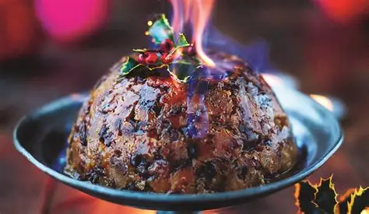

Christmas Pudding
- Evolved from “plum porridge” eaten in medieval Britain—a thick, spiced stew of meat, dried fruit, and wine.
- By the 1700s, the meat was removed, and it became more like a dessert.
- The Victorians finalized the recipe: steamed, full of raisins, spices, suet, and alcohol.
- Traditions include:
  - Stir-up Sunday (mixing it the last Sunday before Advent)
  - Adding coins or charms
  - Setting it on fire with brandy for spectacle

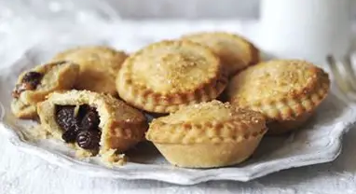
Mince Pies
- Medieval mince pies did contain meat (usually mutton) mixed with fruit and spices, ingredients symbolizing the Middle East and the Nativity.
- By the 18th century, the meat was phased out, leaving the sweet “mincemeat” we know today.
- Traditionally:
  - They were originally oval, representing the manger.
  - Eating one pie on each of the 12 days of Christmas was said to bring good luck.

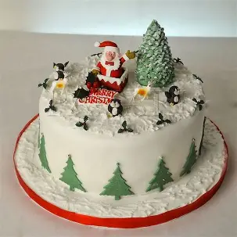
Christmas Cake
- Originated from “Twelfth Cake”, eaten on Twelfth Night (6 January).
- Fruitcake became linked with Christmas during the Victorian period, partly due to the popularity of marzipan and icing.
- Often decorated with snowy scenes or figurines.

Chocolate Yule Log
- Based on the ancient Yule log tradition: burning a large log to ward off evil during the winter solstice (a Norse and pagan custom).
- In the 19th century, French bakers created a rolled sponge cake to symbolize the log.
- This was adopted by Britain as part of the Victorian enthusiasm for pastries and Christmas spectacles.
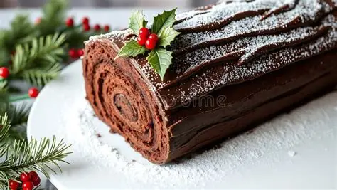

Winter Grown Wonders: How to Grow Food When It’s Freezing Outside
When the nights draw in and frost coats the garden, it’s easy to think that growing food has to wait until spring. But thanks to clever food tech ideas and a bit of imagination, winter can be one of the most exciting seasons for homegrown produce. From mushrooms in cupboards to herbs on windowsills, there are plenty of ways to keep fresh, sustainable food on your plate — even when it is icy outdoors.
Small but Mighty: Microgreens
You do not need a big garden or a greenhouse to grow something delicious. Microgreens are tiny, fast-growing plants that can thrive indoors all year round. All you need is a small tray, a bit of compost or damp kitchen paper, and a handful of seeds such as rocket, radish, mustard, or pea shoots. Within two weeks, you will have a bright green mini crop ready to harvest. These little leaves do not just look good — they are packed with vitamins and minerals, sometimes five times more than their mature versions. You can sprinkle them over soup, mix them into pasta, or use them to top sandwiches for a burst of freshness in the middle of winter.
In food technology, microgreens are an amazing example of efficient, low impact growing. They use very little space and water, making them a great model for urban farming or sustainable catering.

The Magic of Mushrooms
If you like science experiments, growing mushrooms is the perfect project. Mushrooms do not need sunlight at all — just a dark, cool, damp space. You can buy simple grow kits online or make your own by mixing mushroom spores with coffee grounds or straw inside a cardboard box. Over the next few weeks, white threads called mycelium spread through the mixture until mushrooms begin to form.
It is fascinating to watch, and the results are delicious: oyster, shiitake or even pink mushrooms that taste incredible fried with butter and garlic. Mushrooms are full of nutrients too, including vitamin D, which helps replace what our bodies lose during the darker months. It is also a great way to recycle — coffee grounds that would otherwise be thrown away become the perfect growing medium.

Green Windowsills
Herbs are another painless way to grow food during winter. Parsley, mint, thyme, chives, and oregano all thrive indoors if they get a little light. Keep them on a sunny windowsill, water them lightly when the soil dries out, and trim them often to encourage new growth. If you want to bring some technology into it, you can use small hydroponic kits — systems that grow plants in water under LED lights instead of soil.
These kits are becoming popular in kitchens and classrooms because they show how future farms might work: using sensors, smart lighting, and nutrient solutions to grow food without relying on seasons or weather. Imagine harvesting a handful of basil leaves in January to add to your homemade tomato soup — all thanks to a little bit of science on your windowsill.

Frost Fighters: Outdoor Winter Veg
For those with access to a garden or even a few outdoor pots, there are plenty of vegetables that actually prefer the cold. Kale, spinach, carrots and leeks can all survive freezing temperatures, and in fact, some — like kale and carrots — taste sweeter after a frost.
The trick is protection. Covering your plants with a simple layer of fleece or using clear plastic bottles as miniature greenhouses traps warmth and keeps frost off the leaves. It is an easy, low-cost way to keep crops growing until spring. Growing these hardy vegetables shows just how resilient nature can be - and why eating seasonally is such a key idea in modern food technology.

Future Farming: Food Tech Takes Over
If you look at what is happening in cities around the world, you will see that winter farming is already being transformed by technology. In London, the company Growing Underground grows salad leaves thirty metres below the streets of Clapham using pink LED lights and hydroponic systems. No soil, no sunlight, and zero food miles. In Finland, “plant factories” grow strawberries year-round in completely climate-controlled environments. And in supermarkets across Europe, in cabinets grow herbs right beside the fruit aisle so they can be picked fresh the same day.
These futuristic systems use robotics, data sensors, and renewable energy to make food production more efficient and sustainable. They prove that farming does not have to stop when temperatures drop — it can move indoors, upwards, or even underground.
Creative Winter Growing
If you would like to experiment further, try regrowing vegetables from scraps. Spring onions, lettuce, and celery will all regrow from their root ends if placed in a shallow glass of water. Garlic cloves planted in small pots will sprout into garlicky green shoots that make a great topping for salads and soups. Even potatoes can be grown in a bucket of compost kept in a shed or covered patio — by early spring, you will have a small crop of baby potatoes ready to eat.
A Taste of the Future
Growing food in winter isn’t just about saving money or eating fresh — it is about understanding where our food comes from and how technology can help us produce it more sustainably. From microgreens on your windowsill to mushrooms in your cupboard, these small experiments connect science, creativity, and sustainability in a way that feels hands-on and rewarding.
So next time you are stuck inside on a cold day, why not start a little winter garden of your own? With a few seeds, a bit of curiosity, and a sprinkle of innovation, you can turn even the darkest months into a season of growth.
A Taste of King’s (Christophe Charpentier)

- What inspired you to become a chef? Please feel free to explain your journey to becoming Head Chef at King's.
As a young man, I was very lucky my mother and Grandmother were excellent cooks; I was always interested to know how they cooked the meals. I did an apprentice for 2 years and came to work in England to work in a French restaurant, worked my way up to Head Chef and started to work at King’s in 2016.

- Growing up in France, what are some of your earliest food memories or favourite dishes?
My Grandparents used to have a big vegetable garden and grew everything; only eating seasonal vegetables. I loved to eat to eat all those fresh vegetables. My favourite dishes are shellfish, Ribeye steak and dauphinois potatoes, roast rack of veal, and many sauces. It is very important that food is well sourced.

- What is your favourite meal - please feel free to mention everything from starters to main course to pudding - and your favourite drink!
My favourite meals are oysters or homemade soup, mussels, scallops or a lamb dish, apple tatin or chocolate fondant.

- What does a typical day look like for you?
A typical day includes getting up at 5.30am to walk my dog, at work for 7pm, finish at 4pm, walk the dog when back home and relax.

- How do you balance creating meals that are both healthy and delicious?
It is very important to use fresh ingredients and to know what goes with what and to make sure it is cooked perfectly.

- If you could teach students one kitchen skill or cooking secret, what would it be?
I will teach them how to cook each vegetable, meats, fish, sauces, and desserts.

- What advice would you give to anyone who might want to pursue a career as a chef?
Be passionate about food, be a hard-worker and working many weekends.

- Where is your favourite place in the world?
I have a few: Malta, Antibes in France and the Peak District in England to name a few.

- Do you have an interesting fact/hobby/skill that no one else knows? It doesn't have to be related to your job!
I love cycling, reading, and walking my dog. A few years ago, I used to build stages for the Music Entertainment, and I am a good climber.

- If you hadn't been a chef, what else might you have done?
My Grandad used to have his own garage; I wanted to work as a Car Mechanic.

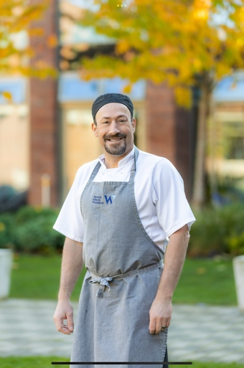

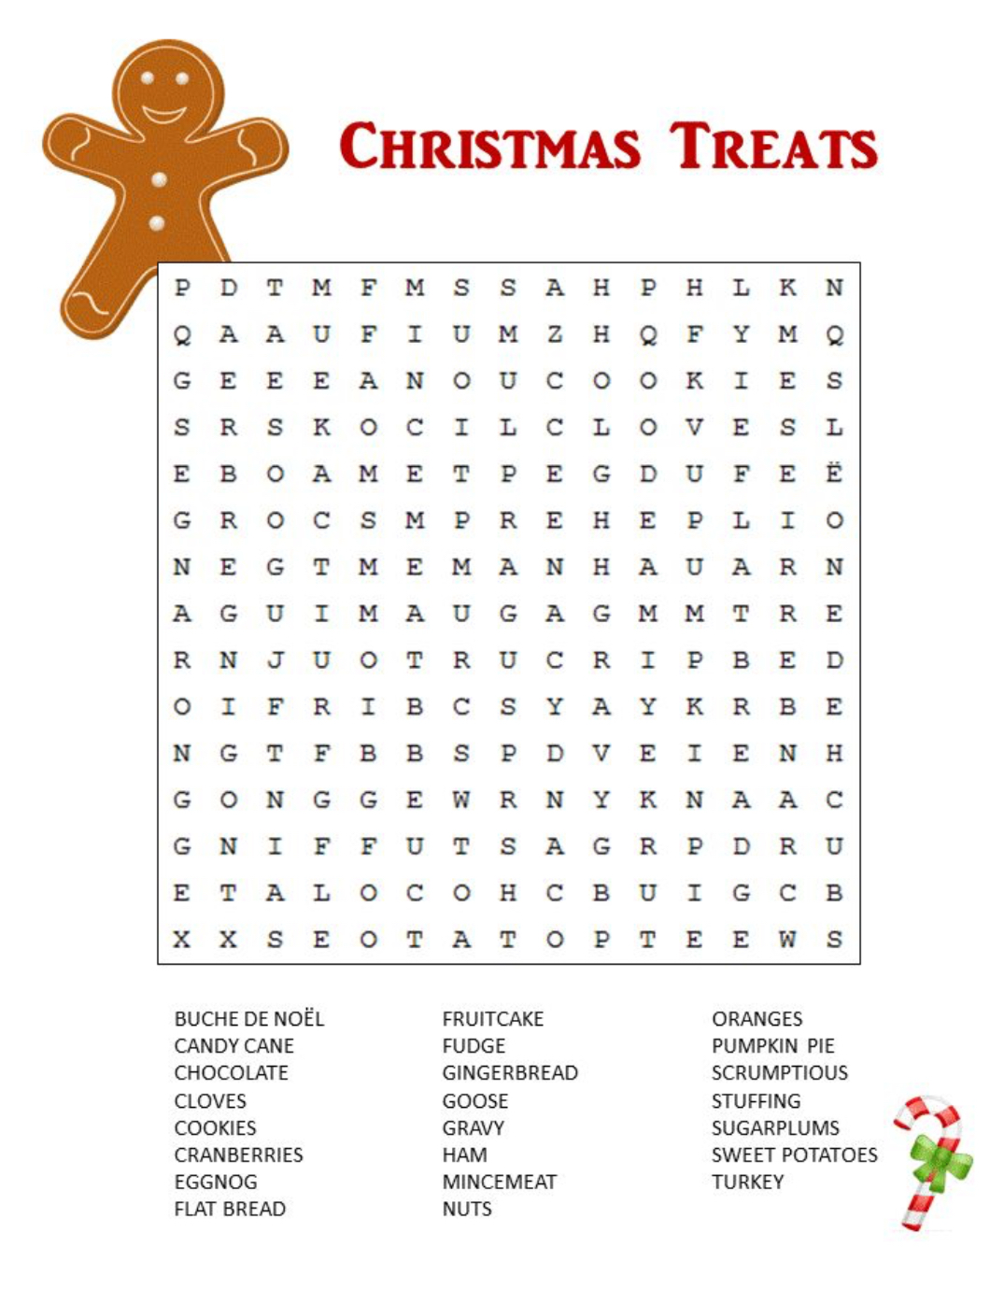

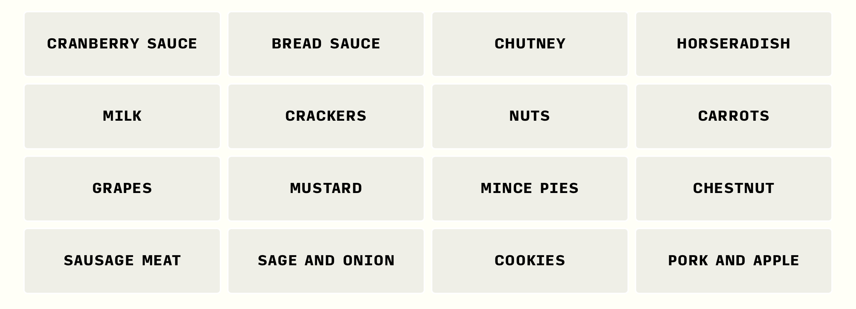
Please email your answers to Mrs Gregory or Mrs Featherstone, if you get the correct answer, you will get a prize!!!!

Christmas Connections

