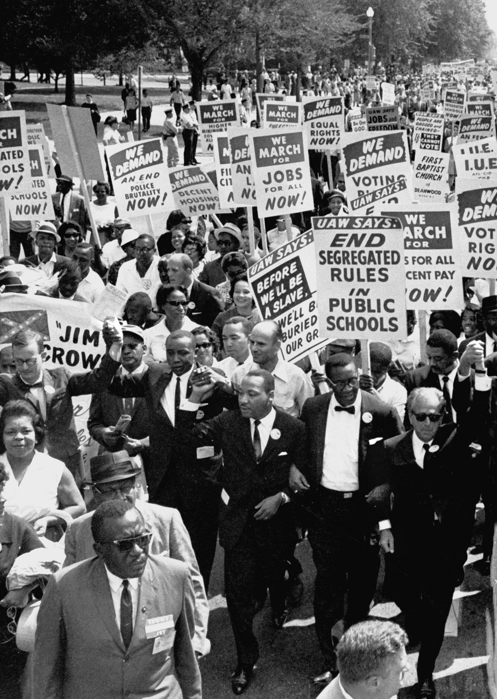
HOBBS SOCIETY AUTUMN TERM:
RACIAL JUSTICE
Pirasha Ramesh and Maud Beidas
Who we are:

Hobbs Society is a student-led society, names after philosopher Prof. Angie Hobbs, that previously brought in speakers to give careers-based talks. This year, we saw an opportunity to change the focus. Our aim is to educate all girls about prevalent issues and basic injustices within our society. We want to inspire, motivate and encourage them to make active change by giving them the necessary tools to do so. We believe that education is vital to make a difference in a prejudice society, not just locally but worldwide. This term we focused on racial justice and our four speakers gave talks about their own personal experiences with racism. Each gave a new perspective and offered valuable advice to pupils about how they can tackle discrimination within the school community.


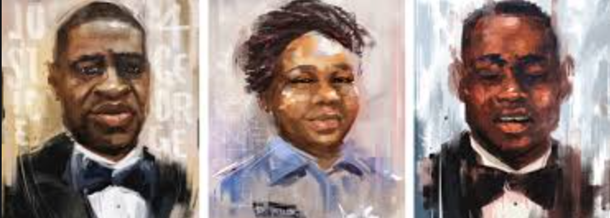
The speakers this term:

- Shianne Williams
- Pirasha Ramesh
- Joana and Joshua Simango

SHIANNE WILLIAMS
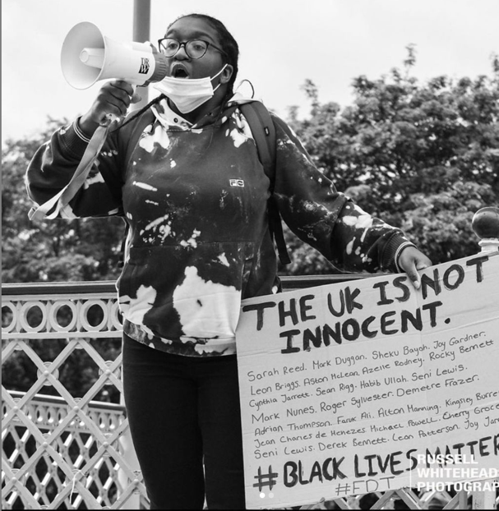
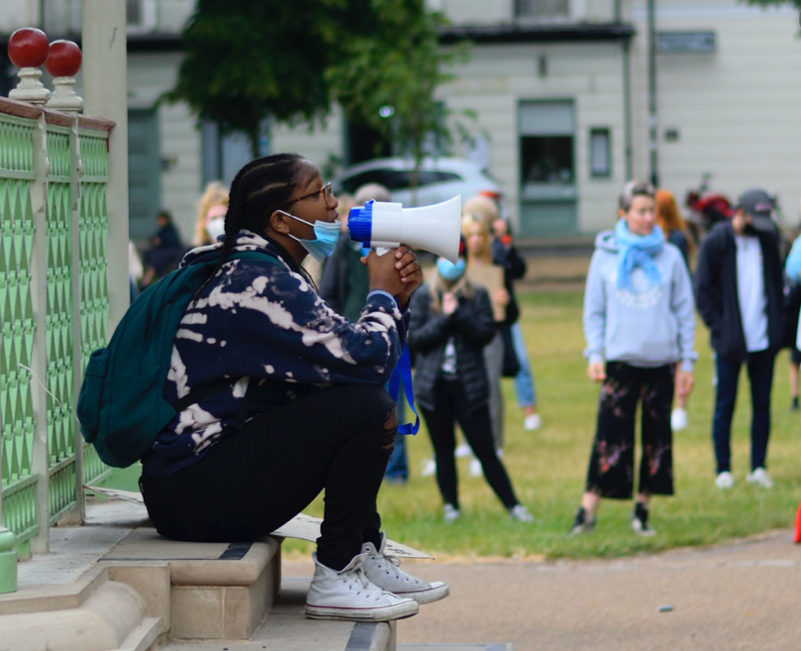
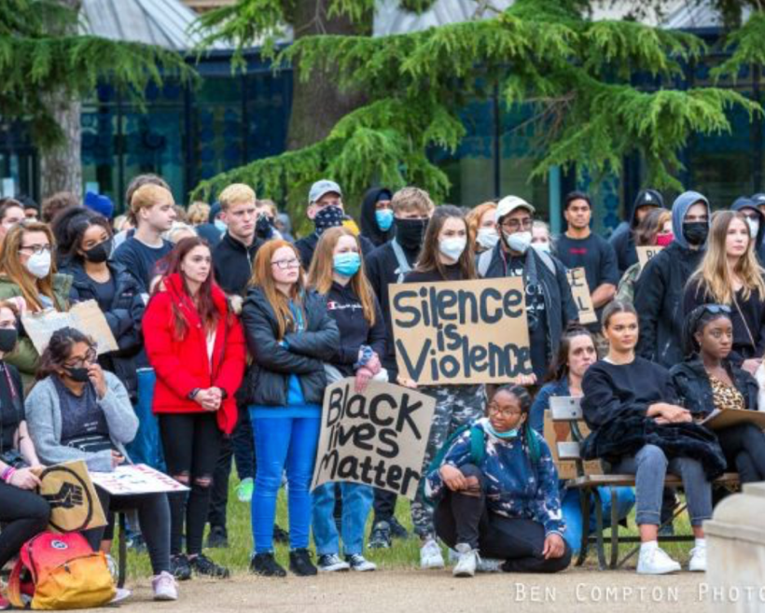

17-year-old, Shianne Williams started the term with an insightful question and answer session. Shianne has been a leading figure in the organisation of peaceful protests in the local community, which raise awareness about racism in the UK. She talked about the importance of educating people on the topic of race and how crucial it is to hear from people about their own experiences of discrimination. She encouraged the girls to start pushing for racial justice at a school level and raised the question of equity or equality. Pupils have remarked that the highlight of the event was being able to ask how we can make positive change in the school community
and learning about the thin line between cultural appropriation and cultural appreciation from Shianne’s personal accounts.

PIRASHA RAMESH

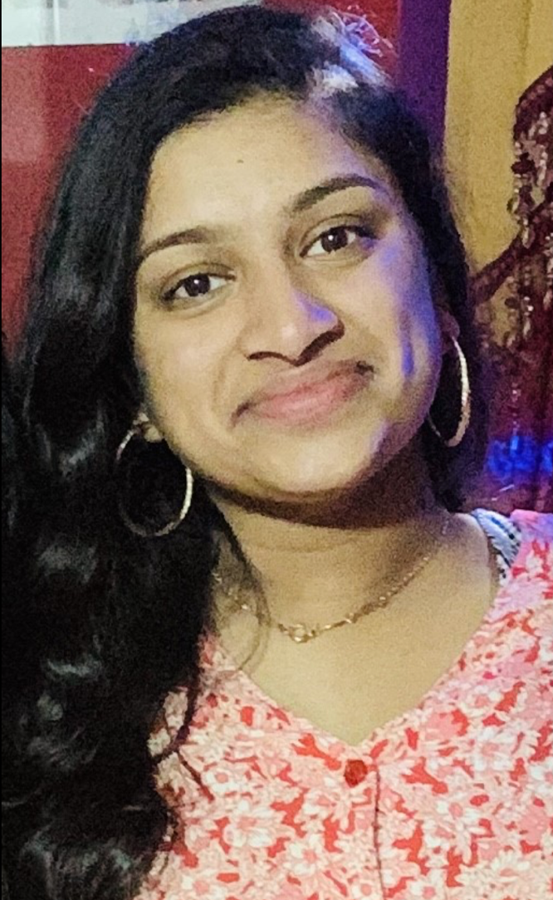
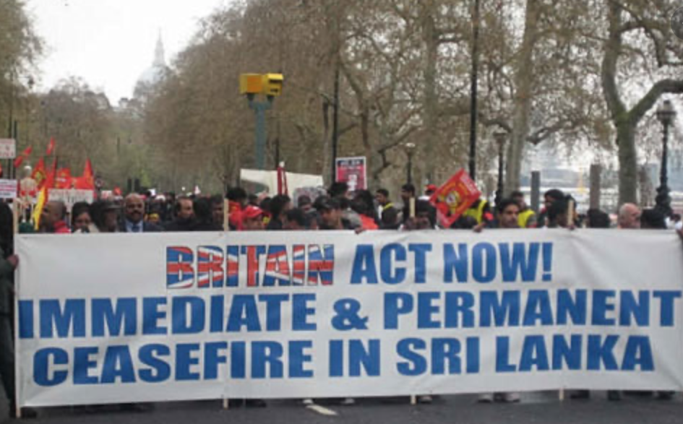
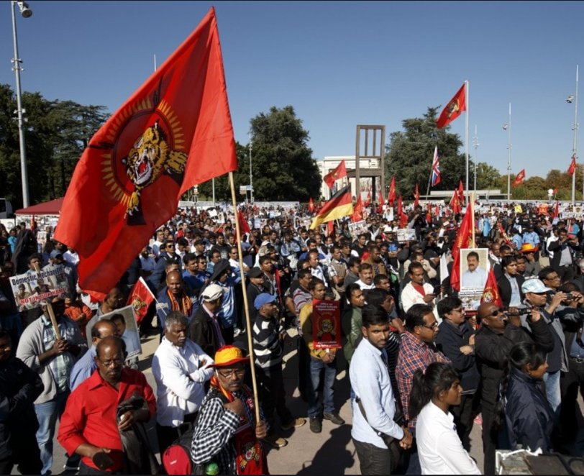
Our second talk called “Being British and Being Brown” was given by Lower Sixth pupil Pirasha Ramesh. She spoke about her life as a first generation British-Tamil and the difficulties of being a young girl of colour in this day and age. She told the girls how the Sri Lankan War and the Tamil Genocide had an impact on her parents as well as herself. These two events have little representation in the curriculum and yet, it affects many students not only in King’s High, but also throughout the country. Pirasha explained to the girls that growing up with two cultures and learning to adapt to her surroundings was an incredibly difficult experience. She spoke of her fear for her own future as well as the futures of young people of colour in the UK and how she has not seen a brown woman with a similar upbringing to herself be at the top of their industry. Her motivation for success is to be that role model to young women of colour. The most rewarding thing about the talk was that Pirasha’s words encouraged other pupils in the audience to speak about their experiences with racism, for she had created a safe and supporting environment
JOANA SIMANGO AND JOSHUA SIMANGO

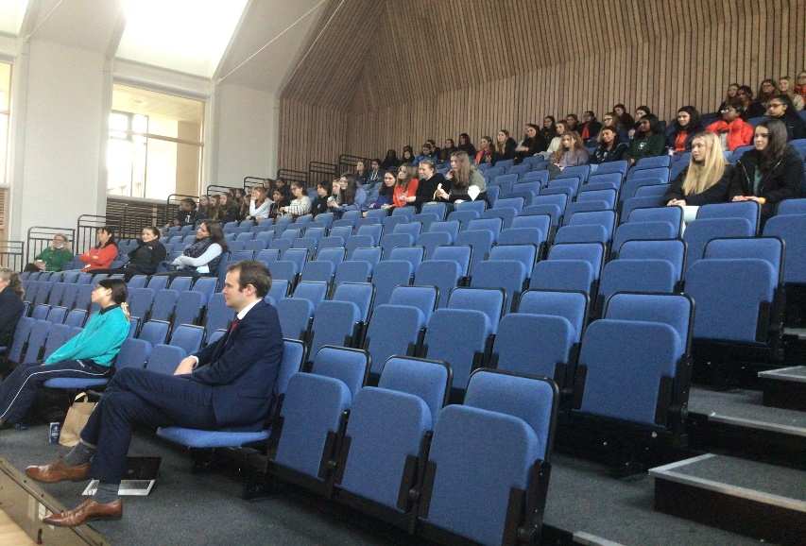
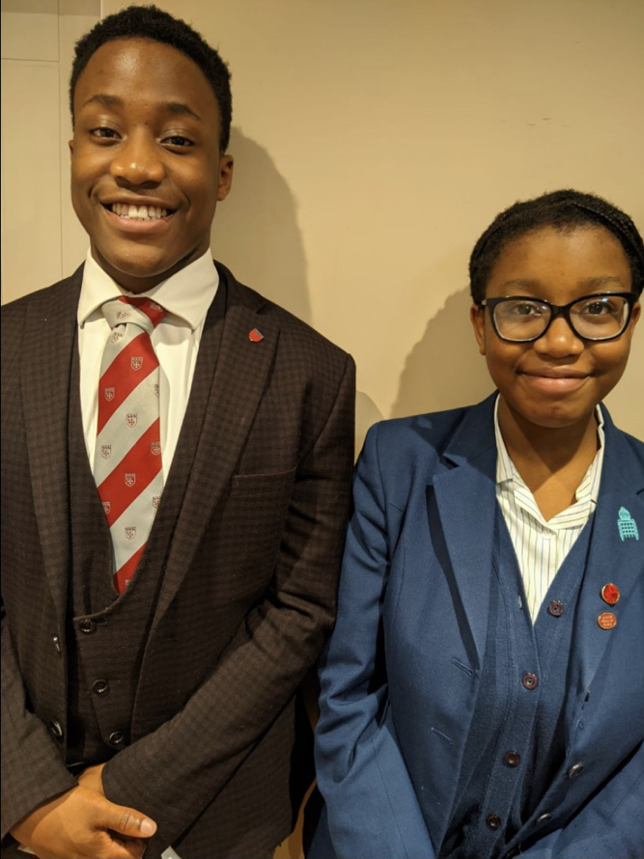
The rest of the talk was given by the hugely inspirational Joana Simango who answered questions from the audience as well as speaking about her life as a young black girl growing up in the UK. She commented that the people’s perception of the “aggressive black woman” stereotype overshadows her friendly and outgoing personality. Owing to this, Joana will no longer stand by and accept such racism. Racism is the barrier between people of colour and success. Joana did not shy away from the painful reality of this as she said “being black and female in any industry is hard” and having that realisation from such a young age is hugely worrying. Society is letting her, and so many others, down. The talk ended with a standing ovation for both Joana and Joshua from an audience of more than 60 staff and students.
Our final talk but by far the most powerful was “My Colour Killed Me”, delivered by Year 9 Pupil Joana Simango and her brother, Upper Sixth student and Head Boy of Warwick School, Joshua Simango. We started with a recorded message from Joshua talking about his time in a predominantly white school. He felt that sometimes his achievements were unintentionally justified by the colour of his skin. He has received comments that he did not fit the “black” stereotypes since he is “smart” and “too nice”. He also said that students enter a Caucasian bubble and are not exposed to true racism until they enter the real world. To tackle racism, we need to embrace diversity and willingly learn about a variety of cultures.

This term has been extremely successful for the Hobbs Society. It is truly heart-warming to see girls and staff not only continuing the discussion but educating themselves about the issues people of colour face daily. We have felt so much gratitude for those of you that have come forward and spoken about your experiences with racism. We would love to encourage that further because as we have heard through our talks, it is so important that the community learns from you.

We will not stop fighting for racial equality on a local and global level and we are not going to forget about the need for racial justice. There are simply not enough hours in the day to address every social inequality, but we will do our best to cover as many as possible. That being said, next term our focus is ableism, a topic we believe is just as important. We will be opening the term with a talk from external speaker, Nicola Enoch, about Down’s syndrome.

We look forward to seeing the continued support for Hobbs Society next term.

Maud Beidas and Pirasha Ramesh

